**Test cases fix for admin:**

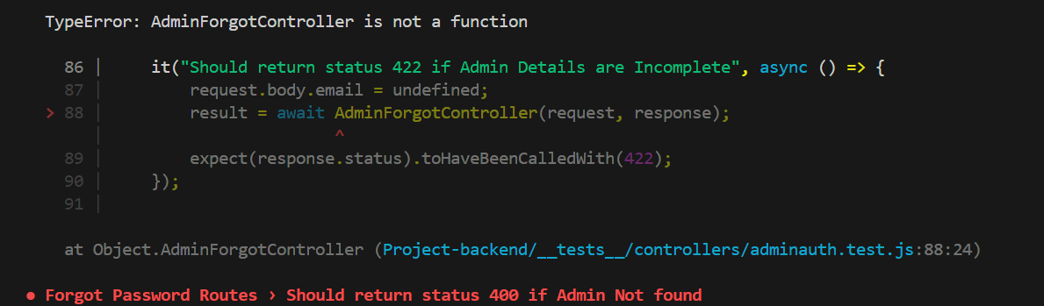

**Issue**:

**Return Statement Issue with res.status() and res.json()** In the controller, the following syntax

return res.status(422), res.json({ message: 'Please fill all fields' });

**Resolution**:

res.status() and res.json() to ensure that both are executed as expected:

return res.status(422).json({ message: 'Please fill all fields' });

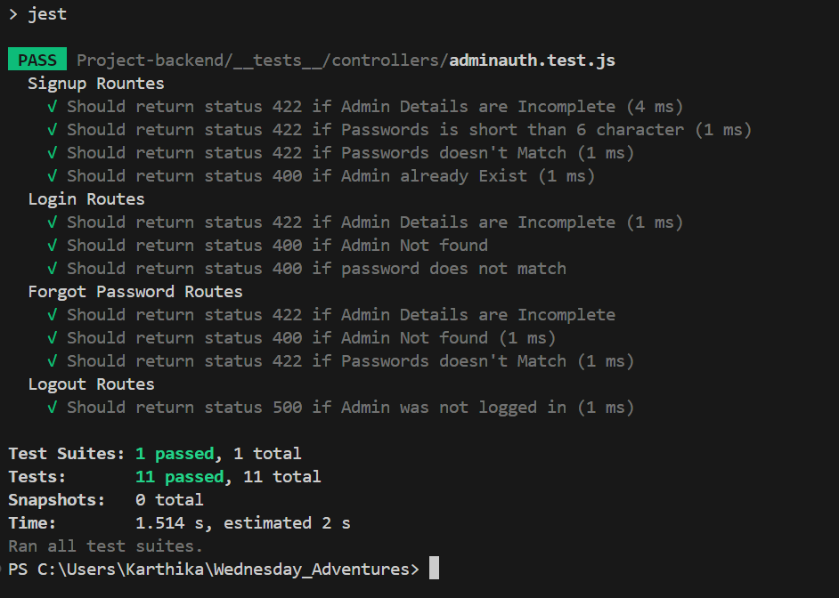

**Admin frontend integration:**

1. The issue was with handling it with DOM of the entire component so the data was not updating correctly due to useState innate working. So changed to the DOM of the AntD third party component and the value handling for email and password for login 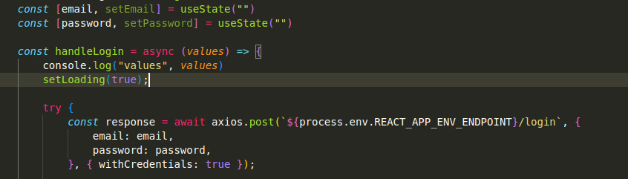

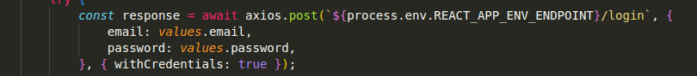

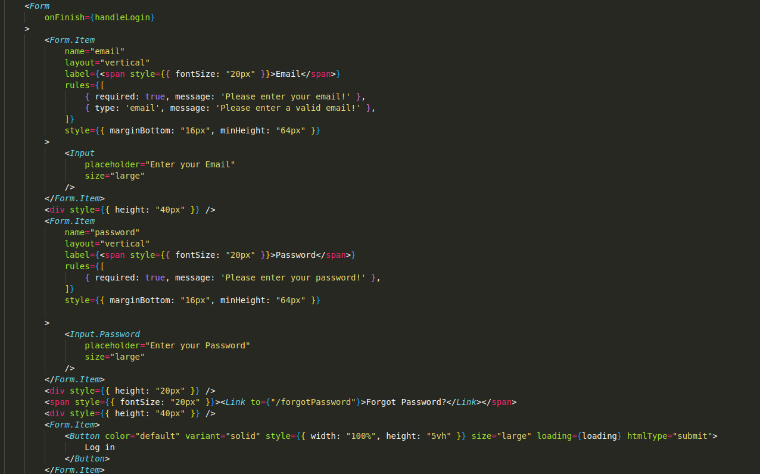

1 (a) User register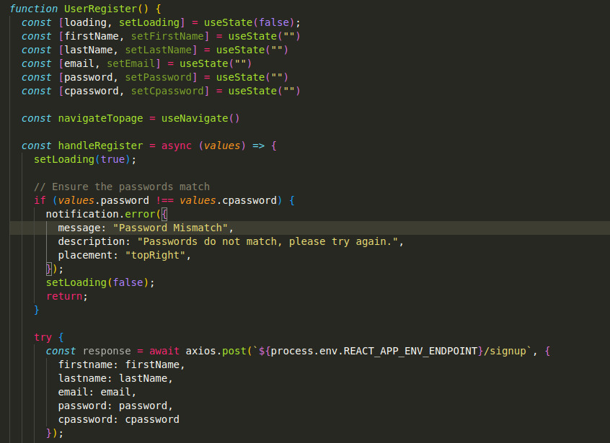

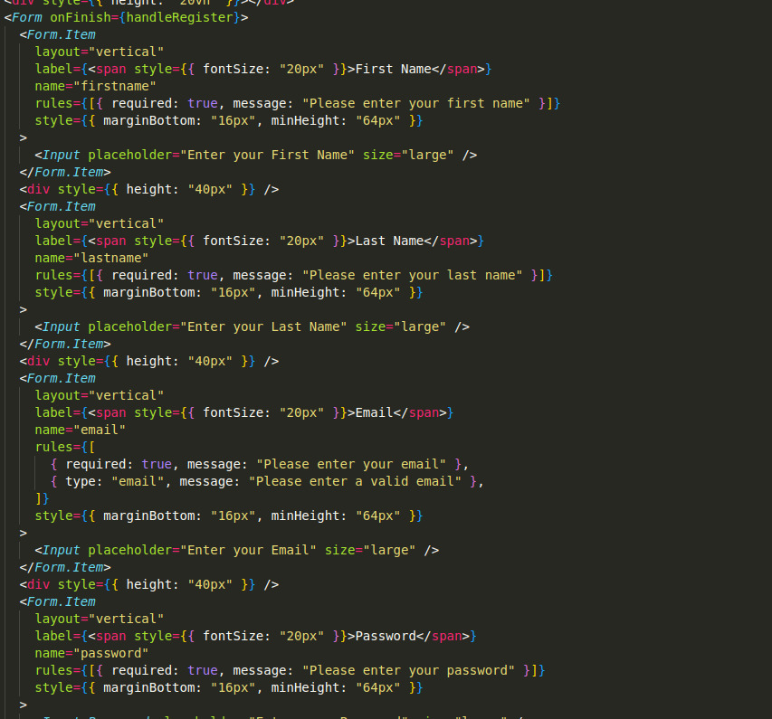

1 (b) Forgot Password

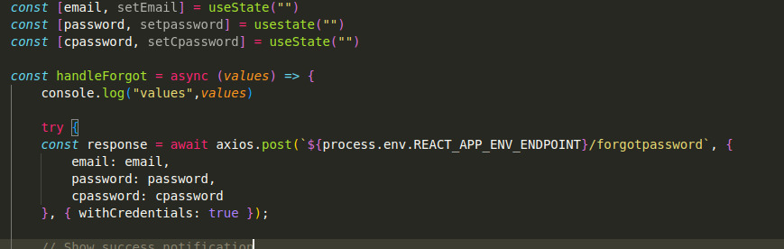

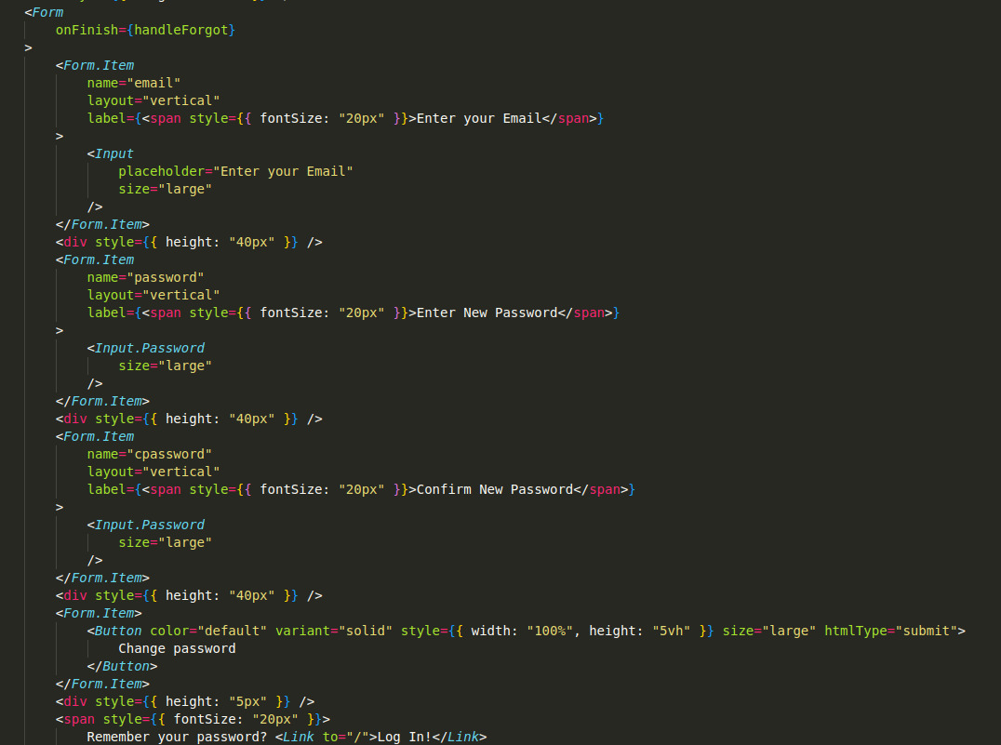

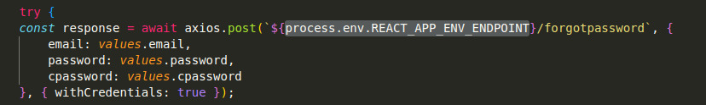

1. Did not have the configuration of app listed correctly with the port and was ambiguous

so resolved with env config instead of hard coding.

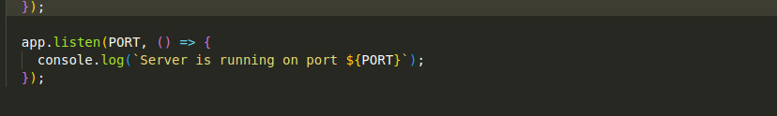

1. CORS was not working correctly with https package for API. So, we used AXIOS for credentials versatility for API Integration in the react app.

